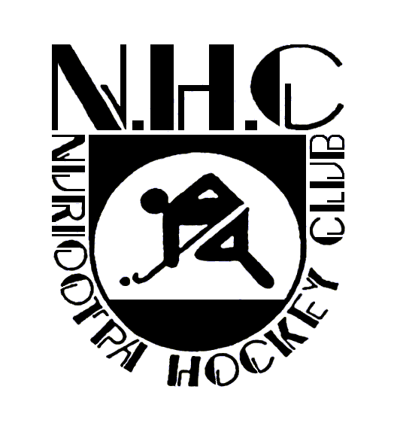

**NURIOOTPA HOCKEY CLUB – JUNIOR POLICY**

All members of a team will be considered as having an equally important role to play, regardless of gender, age, ability or position on the field.

As near as possible players (in full field teams) should receive equal playing time throughout the season, dependant on attendance, reliability and attitude at training. During finals all players should be given a “fair go” and receive reasonable time on the field. The Club acknowledges that children play sport for various reasons and that a lack of playing time is a major reason for children “dropping out” of sport.

Junior players will be encouraged to play in their own age group and will only be offered a second match in a higher grade if insufficient numbers in that higher grade.

Players playing their second match for the day should start on the bench if there are more than eleven other team members present.

Occasionally, there may be exceptional circumstances where a player may wish to play out of there age group. Players wishing to play out of there age group must submit a written request addressed to the NHC President and the Junior Coordinator. If a request is granted, it is only for the current season. A new request must be submitted each year.

Junior players regularly playing a second match should attend training for that second team if at all possible.

**Grievance Procedure**

If a player/parent has any complaint relating to the selection in a particular team it should be escalated as follows:

* To the Junior Coordinator, who in the first instance will attempt to gain resolution with the coach and team manager for the respective team(s).
* To the NHC Committee, at its next meeting. Players and parents are to accept the decisions of the Junior Coordinator and the Committee.

Authorised and Endorsed by the Nuriootpa Hockey Club Committee 2022

Brad Fairey

President